DeJanae Faison

3/23/2025

Assignment 1.3: Building a Web Page Exercise Part 1

First Validation:

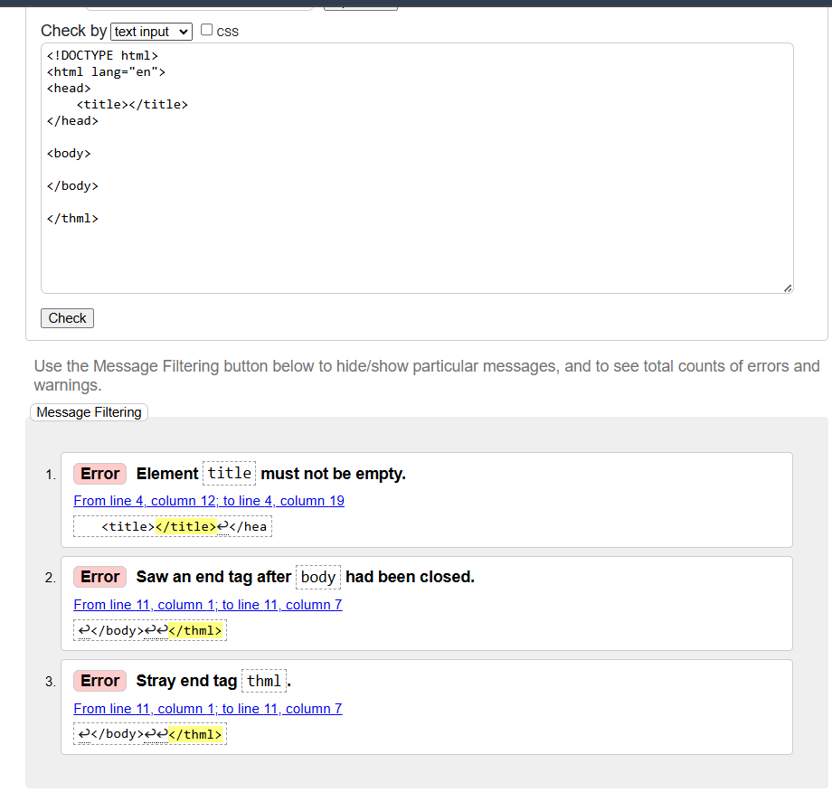

Second Validation after corrections:

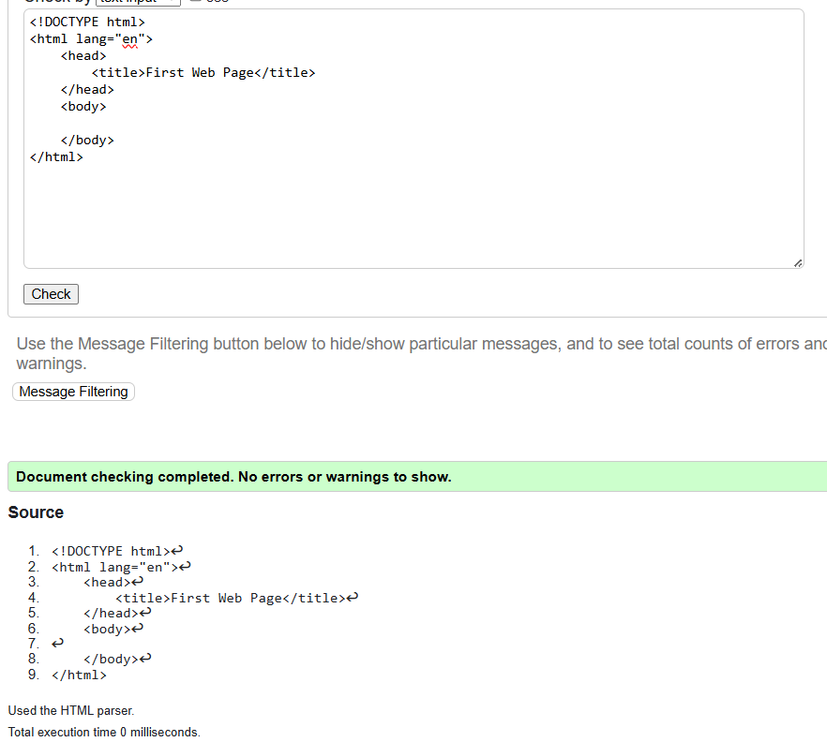

Third Validation:

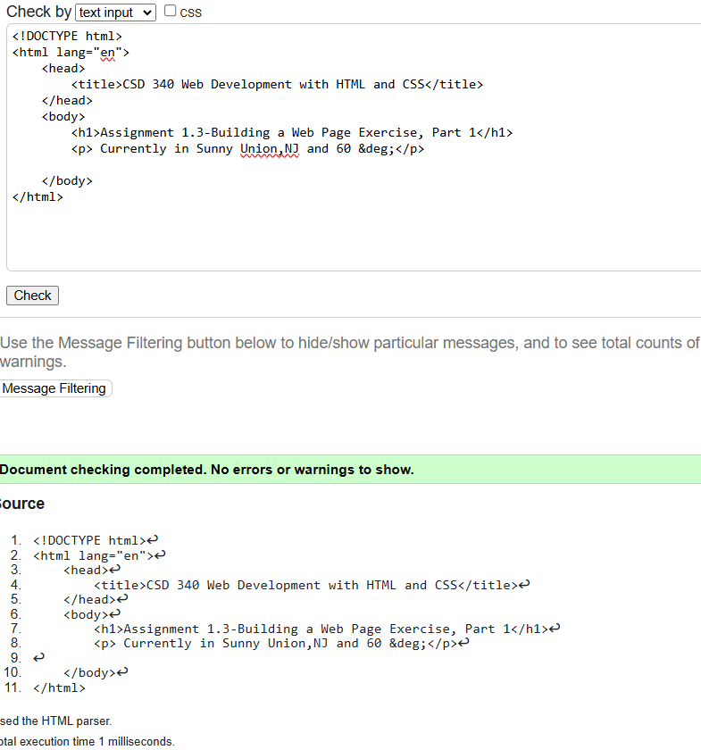

Web Browser:

